Homework 2

Qinghua He

qh2297

Q1.

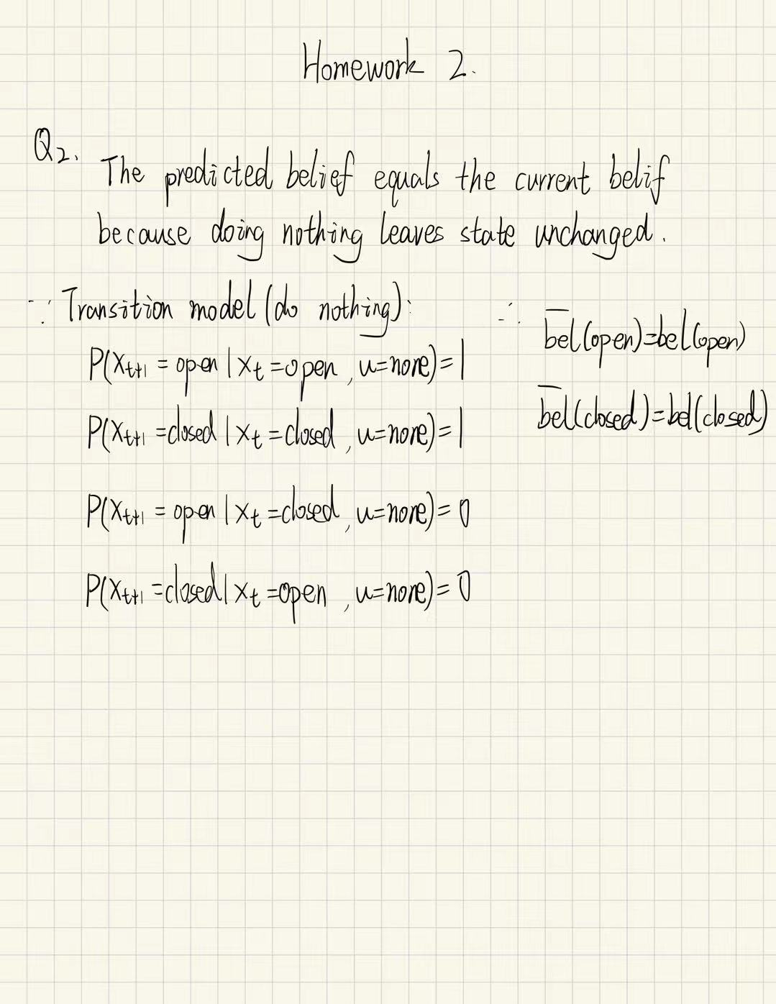

Q2.

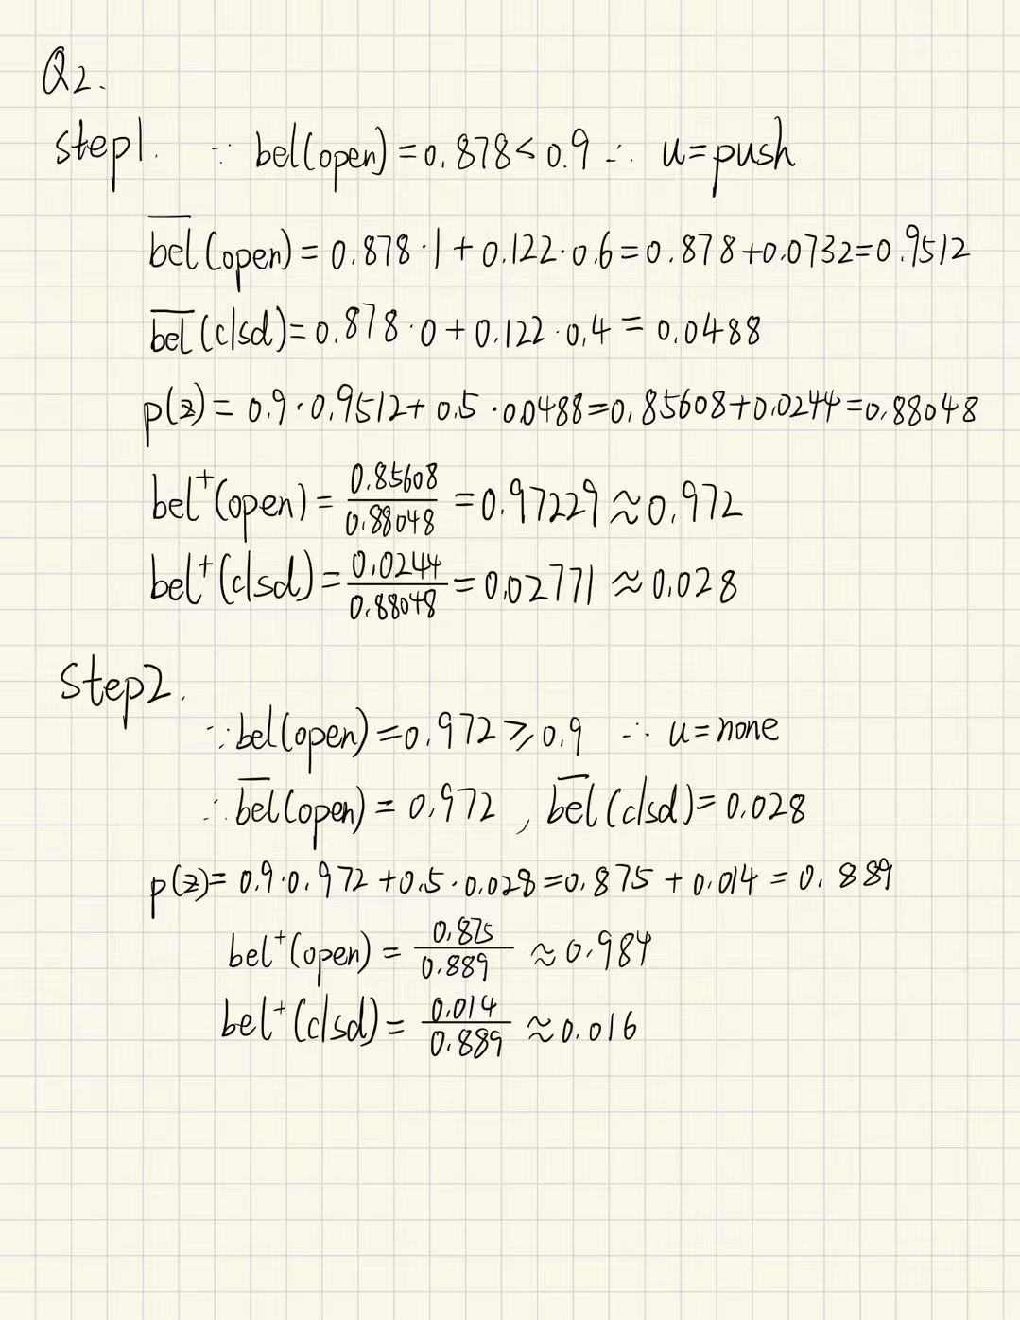

|  |  |  |  |  |  |  |  |
| --- | --- | --- | --- | --- | --- | --- | --- |
| step | bel(open) | bel(clsd) | action | bel(open) | bel(clsd) | bel+(open) | bel+(clsd) |
| 0 | 0.5 | 0.5 | push | 0.800 | 0.200 | 0.878 | 0.122 |
| 1 | 0.878 | 0.122 | push | 0.951 | 0.049 | **0.972** | 0.028 |
| 2 | 0.972 | 0.028 | measure | 0.972 | 0.028 | **0.984** | 0.016 |
| 3 | 0.984 | 0.016 | measure | 0.984 | 0.016 | **0.991** | 0.009 |
| 4 | **0.991** | 0.009 | go! |  |  |  |  |

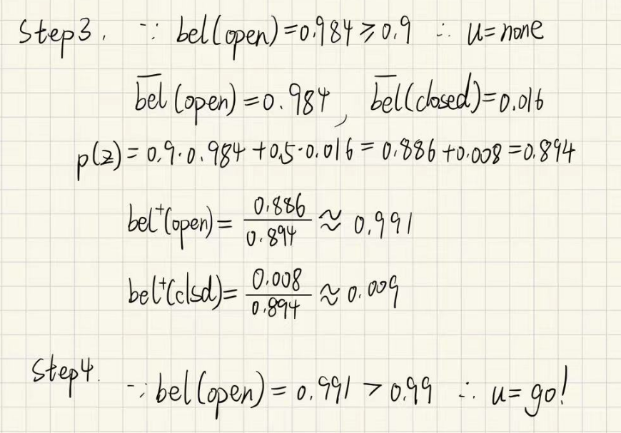

Q3.

Code link:

[add h2 code · White8848/Probability-Robot@4969b10](https://github.com/White8848/Probability-Robot/commit/4969b10904c59572f66e77d7df8b260e1374aebb" \l "diff-fbb29bebe0cc03f8786569a68ca1c467aa2328ca5fd789b43a290a5e09c43048)

